

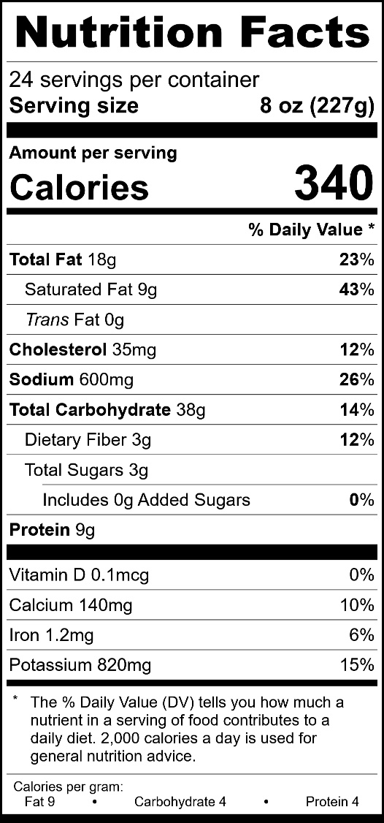



**8 oz. Bacon Cheddar Twice Baked Potato**

**Product Item #35510**

• Delicious lunch or dinner entrée

• Satisfying 8 ounce serving

• IQF - easy to reheat with a microwave or oven

• Restaurant quality

• Satisfaction guaranteed

**Ingredients:**

Baked Potato, Sour Cream (Cultured Pasteurized Milk And Cream, Whey, Modified Corn Starch, Sodium Phosphate, Guar Gum, Carrageenan, Calcium Sulfate, Cultured Dextrose, Potassium Sorbate [Preservative], Locust Bean Gum), Cheddar Cheese (Pasteurized Milk, Salt, Cheese Cultures, Enzymes, Contains Less Than 2% Annatto), Water, Butter (Cream, Salt), Margarine (Soybean Oil, Water, Contains 2% or less of: Salt, Hydrogenated Soybean Oil, Mono- And Diglycerides, Soybean Lecithin [Soy], Sodium Benzoate [Preservative], Artificial Flavor, Beta Carotene [Color], Vitamin A Palmitate Added), Fully Cooked Bacon (Pork Cured With Water, Salt, Sodium Erythorbate, Sodium Nitrite. May Also Contain Sodium Phosphate, Sugar, Smoke Flavoring, Potassium Chloride, Dextrose, Honey, Potassium Lactate, Sodium Diacetate, Flavoring, Brown Sugar), Salt, Xanthan Gum, Onion Powder, Chives, White Pepper.

Contains: Milk, Soy

**Cooking Instructions:**

**Conventional Oven:** Preheat oven to 350ºF.

Bake for 60 minutes from frozen, or 35 minutes if thawed, to an internal temperature of 165°F (74°C). The ridges will be browned and the potatoes should be heated throughout.

**Microwave Instructions** (Frozen)

Remove the plastic wrap and heat in microwave for

4 – 4 1/2 minutes from frozen, or 2 – 2 ½ minutes if thawed, to an internal temperature of 165°F (74°C).