 **VF America, LLC.**

Product Specification 4507

**PRODUCT NUMBER:** 4507

**PRODUCT NAME:** Golden Krust Chicken Wings, Jerk Seasoning Flavor

**PRODUCT SUMMARY:** Chicken wing portions, tumble seasoned, fresh packed and IQF’d. Product is packed net 5.0 lbs (80 oz) per sealed bag. Product is packed 8 bags in a case for a net weight of 40 lbs. Product is shipped frozen.

**CASE GTIN:** 4507-JW

**CASE BARCODE:** 859987074258

**­ALLERGENS:**

**Contains?**

Dairy – No Fish – No

Eggs – No Peanut – No

Soy – Yes Shellfish – No

Wheat – No Tree nuts – No

**INGREDIENT STATEMENT:**

Chicken wing portions, jerk marinade ([onion and citric acid], water, salt, spice, vinegar, natural smoke flavor, brown sugar, garlic puree, monosodium glutamate, dehydrated green onion, natural scotch bonnet chili flakes, xanthan gum, turmeric, citric acid, celery seed, paprika), General Seasoning (monosodium glutamate, salt, brown sugar, spices [including celery seed], hydrolyzed soy protein, dextrose, garlic powder, corn starch, sugar, dehydrated onion, paprika, yeast extract, caramel color, paprika oleoresin [for color], turmeric, natural flavors, not more than 2% dioxide added to prevent caking).

**CASE WEIGHT: TARGET**

**40** LBS NET WEIGHT

**PACKAGEING SPECIFICATIONS:**

**44-5 Box Description**

**Length 23.375”**

**Width 15.5”**

**Height 7.875”**

**Case Cube 1.65**

**Inner Package Information:**

**2049 Polyethylene**

**Length 13”**

**Height 15”**

Page 1 of 2

**PALLETIZING REQUIREMENTS:**

**Cases per Layer 5** ea

**Layers per Pallet 8** ea

**Cases per Pallet 35** ea

**Pallets per Load 27** ea **Cases per Load** 945 ea

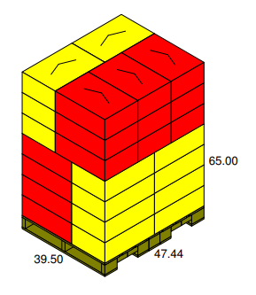

**DATE CODE REQUIREMENTS**

**Lot code as Julian date printed on case label** (EX. 22001)

**PACKAGING IMAGES**

**CASE LABEL**

TBD

Page 2 of 2

Page 4 of x