Seafood Opportunities
Need to move
Two Fish Boil Packs 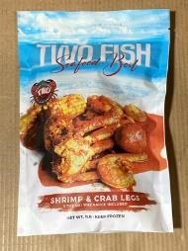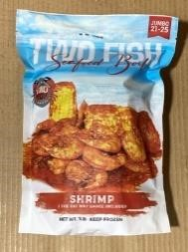

- Each pack has a signature sauce included. This product’s current largest market share is in the Midwest and Southeast.
# 59481 – Crab and Shrimp and Sauce – 20/1# - $ 14.99 per lb.
# 59482 – Shrimp and Sauce – 25/1# - $ 10.19 per lb.
_____________________________________________________________________________________ Better Buys of the week
# 59952 – Jonah Crab Claws & Arms – 10/2# - UPC Printed Bags - $ 11.99 per lb. / $ 23.98 per unit
- A solid value for King Crab in both retail and foodservice
# 66504 – Langostino’s Large IQF – 5/2# - Clear Bag -No UPC - $ 21.00 per lb.
- Back in stock, while the supply continues to be a slight challenge, we now have product back in stock.
# 28232 – Cod Loins 4 oz Pacific – 1/10# - Bulk IQF – No UPC - $ 7.19 per lb.
- A great value priced $ 0.30 per lb. less than our closest alternative.
Kitchens Seafood Sauced and Seared Meals – Packed 12/22 oz – $ 100.08 case / $ 8.34 unit
- All-Natural Shrimp
- Powerful flavors that will not disappoint.
o # 59366 – Shrimp Scampi o # 59367 – Garlic Pesto Shrimp o # 59368 – Shrimp Fra Diavolo
