- Product Description
  - The finished product is made from russet potatoes from the latest season's crop that have been washed, peeled, cut, suitably blanched and frozen. Product is processed following current good manufacturing practices in compliance with the Federal FD&C Act as well as state and local regulations.
  - Ingredients: Russet Potatoes, Dextrose, Sodium Acid Pyrophosphate.
  - Kosher Status: Certified Kosher Parve by Orthodox Union.

- Country of Origin:
  - Potatoes provided by Dickinson Frozen Foods are grown, processed and packaged solely in the United States of America.

- Allergen Statement
  - Dickinson Frozen Foods, Inc. certifies that potatoes produced by Dickinson Frozen Foods, Inc. do not contain any known allergens, as defined by the USFDA.

- Physical
  - Color: The optimum color is white to creamy white.
  - Size: 1/8” x 1/8” x natural length.
  - Fines: <10%. Pieces less than ½”. (Per 100g).
  - Defects (per 100g sample; definitions on page 2).
    - Critical 0 max
    - Major 3 max
    - Minor 10 max
  - Foreign Material: None detected.
  - Extraneous vegetable material: None.

- Organoleptic (after microwave)
  - Flavor and odor: Free of any off-flavor or odor.
  - Texture: Firm potato texture; must be tender and free of fibrous and tough cuts.
- Chemical
  - Must meet federal tolerances for pesticide residue.

- Bacteriological
Aerobic Plate Count | <100,000 cfu/g | AOAC 990.12 or AOAC 2002.07
Coliform | <100 cfu/g | AOAC 991.14 or AOAC 2005.03
Escherichia coli | <10 cfu/g | AOAC 991.14 or AOAC 2005.03
Listeria Monocytogenes | NEG/125g | AOAC 020401

- Defect Definitions
(DEFINITION SET = NORSUN STD mm 2006.05)
* Size limits are based on the area of a circle with the stated diameter (Example: “>4mm” = a defect with an entire surface area that completely fills the area of a circle with a diameter of 4mm).
CRITICAL DEFECTS: | MAJOR DEFECTS: | MINOR DEFECTS:
1) Black Discoloration >4mm  2) Dark Discoloration >8mm  3) Dark Sunburn (green) >4mm | 1) Black Discoloration >2mm  2) Dark Discoloration >4mm  3) Light Sunburn (green) >4mm | 1) Black Discoloration >1mm  2) Dark Discoloration >2mm  3) Light Discoloration >4mm
NON-SCOREABLE: Surface blemishes on the skin of non-peeled products.

- Net Weight
  - Totes: 1000 Lb.
  - Average weight of 10 Units must be ≥ the declared weight.

- Packaging
  - Packaging: Corrugated bulk totes with blue poly liners.
  - Shipping and Storage Temp: At or below 0°F.
  - Shelf Life: 24 months.

- Lot Code Explanation:
  - Format: IJJJYHH (I=Sugar City, Idaho; JJJ=Julian date; Y=Year; HH=Hour code)
  - Example: I244314 = 09/01/2013 between 14:00 and 15:00.

- GMO Statement
  - To the best of our knowledge the Fruitland, ID and Sugar City, ID processing facilities of Dickinson Frozen Foods, Inc. only produce products from vegetables that have not been genetically modified. No genetically modified vegetable varieties are utilized in our products. To assure you that our products are produced from raw materials that have not been genetically modified, we require our growers and packers to provide certificates guaranteeing that they do not supply DFF with genetically modified vegetables.
  - The Fruitland and Sugar City processing facilities of Dickinson Frozen Foods, Inc. are Non-GMO processing facilities now and in the future until further notice.

- MSDS Statement:
  - Per OSHA regulations (1910.1200(b) (5), MSDS sheets are required for hazardous materials. Food is exempt from this requirement (1910.1200(b) (5) (iii), where it states that any food, food additive, color additive, drug, cosmetic, or medical or veterinary device or product, including materials intended for use as ingredients in such products (e.g. flavors and fragrances), as such terms are defined in the Federal Food, Drug, and Cosmetic Act (21 U.S.C. 301 et seq.) or the Virus-Serum-Toxin Act of 1913 (21 U.S.C. 151 et seq.), and regulations issued under those Acts, when they are subject to the labeling requirements under those Acts by either the Food and Drug Administration or the Department of Agriculture.

- Gluten Statement:
  - To the best of our knowledge the Fruitland, ID and Sugar City, ID processing facilities of Dickinson Frozen Foods, Inc. only produce products from vegetables that are gluten-free. No gluten containing products are utilized in our non-seasoned products. Since our products do not naturally contain gluten regulations do not allow labeling of our product as “Gluten-Free” by itself. We currently maintain that the Fruitland and Sugar City non-seasoning processing lines of Dickinson Frozen Foods, Inc. are Gluten-Free now and in the future until further notice.

  - Gluten is a protein that appears in foods processed from wheat, barley and rye.

- Nutritional Analysis (per 100g)
Basic Components |  |  |  | Component | Source Data | Percentage
Calories (kcal) | 86 |  |  | IQF Peeled Russet Potatoes | USDA 11367 | 100%
Calories from SatFat (kcal) | 0.23
Fat (g) | 0.1
Saturated Fat (g) | 0.03
Poly Fat (g) | 0.04
Mono Fat (g) | 0
Trans Fatty Acid (g) | 0 |  |  | 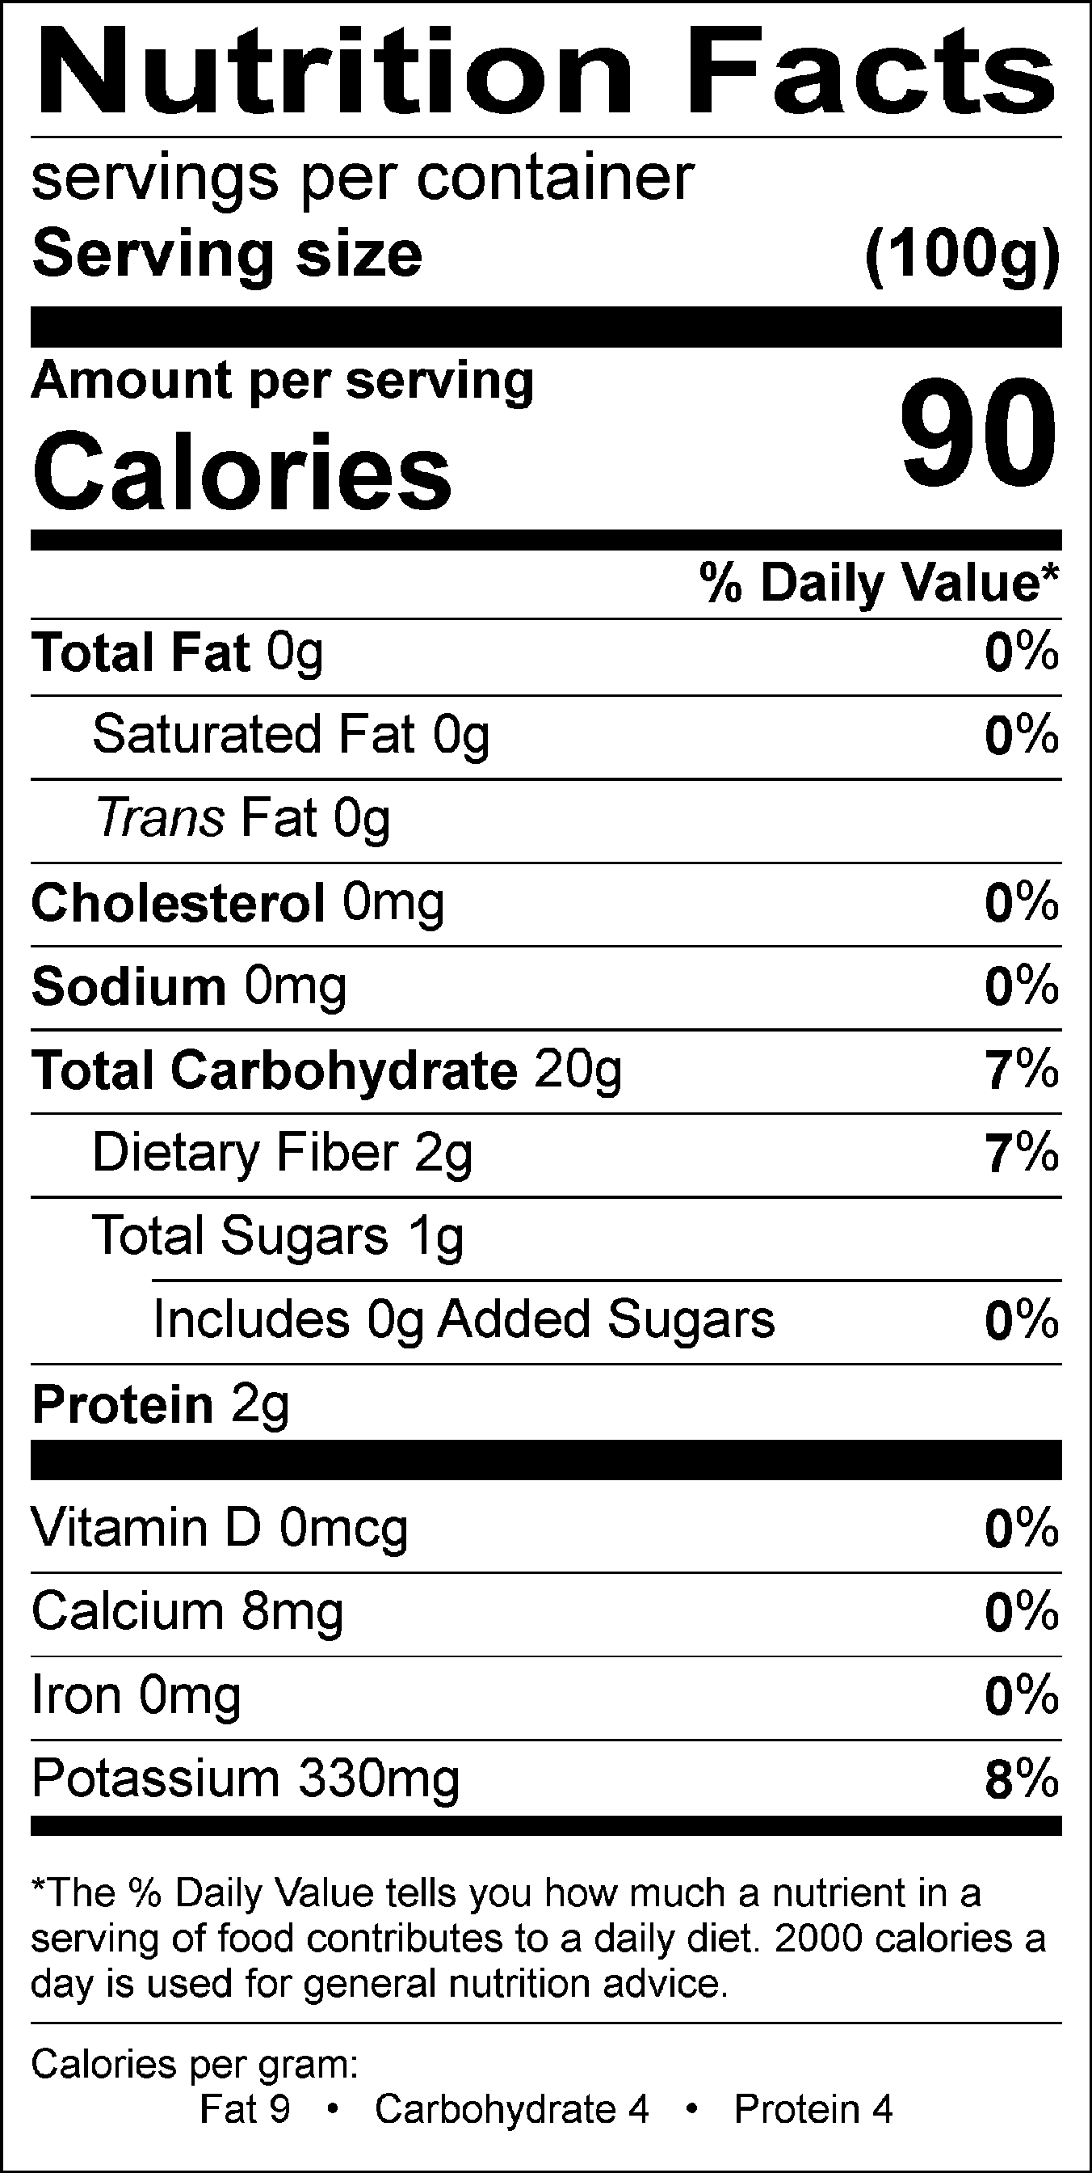
Cholesterol (mg) | 0
Carbohydrates (g) | 20.01
Total Sugars (g) | 0.89
Added Sugar (g) | 0
Dietary Fiber (2016) (g) | 1.8
Soluble Fiber (2016) (g) | 0.68
Insoluble Fiber (2016) (g) | 1.12
Protein (g) | 1.71
Ash (g) | 0.72
Water (g) | 77.46
Vitamins
Vitamin A - IU (IU) | 2
Vitamin A - RAE (mcg) | 0.1
Vitamin D - IU (IU) | 0
Vitamin D - mcg (mcg) | 0
Beta-Carotene (mcg) | 1
Vitamin C (mg) | 7.4
Vitamin E - Alpha-Toco (mg) | 0.01
Vitamin K (mcg) | 2.2
Vitamin B1 (mg) | 0.1
Vitamin B2 (mg) | 0.02
Vitamin B3 - Niacin Equiv (mg) | 1.76
Vitamin B6 (mg) | 0.27
Folate, DFE (mcg DFE) | 9
Folic Acid (mcg) | 0
Vitamin B12 (mcg) | 0
Biotin (mcg) | 0.3
Pantothenic Acid (mg) | 0.51
Retinol RE (RE) | 0
Beta-Carotene Equiv (mcg) | 2
Minerals
Sodium (mg) | 5
Fluoride (mg) | --
Calcium (mg) | 8
Iron (mg) | 0.31
Potassium (mg) | 328
Phosphorus (mg) | 40
Iodine (mcg) | 3
Magnesium (mg) | 20
Zinc (mg) | 0.27

Revision Log

Date | Revisions
07/01/2022 | Document originated.

