UPC CODE
0811991023486
0811991023493
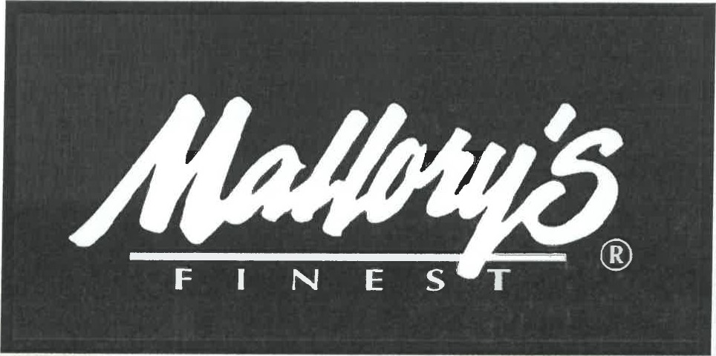

ITEM UNIT COST
CARAMEL JALAPENO CHEESE POPCORN $2.79 EA

CARAMEL CHEDDAR CHEESE POPCORN $2.79 EA
UNIT SIZE: 8 oz.
CASE PACK: 12 units/case
CASE DIMENSIONS: L 19.5 xw 12.875 x H 7
CASE WEIGHT: 7.55 lbs
CASE CUBE: 1.02
PALLET CONFIGURATION: ti x hi 7 per layer 8 High = 56 cases per pallet, 672 units per pallet
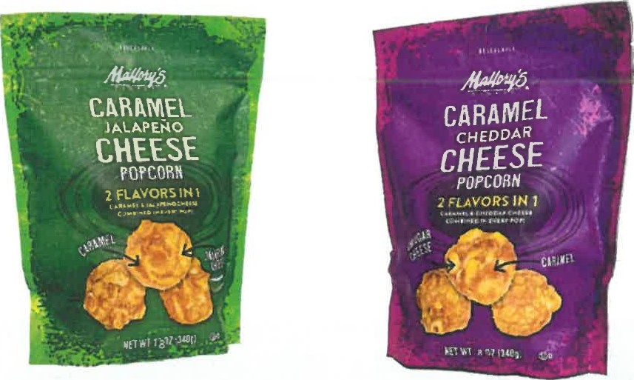

PRICES & PRODUCT SUBJECT TO CONFIRMATION OF ORDER PRICES MAY CHANGE WITHOUT NOTICE
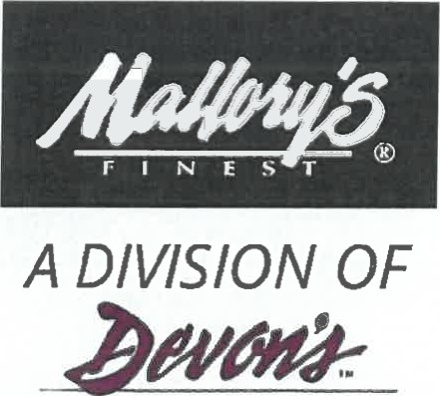
CHOCOLATES

