UPC CODE

0811991023486

0811991023493

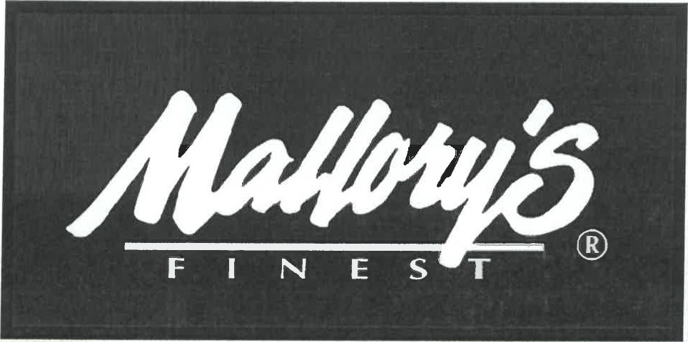

# ITEM UNIT COST

CARAMEL JALAPENO CHEESE POPCORN **$2.79 EA**

## CARAMEL CHEDDAR CHEESE POPCORN **$2.79 EA**

UNIT SIZE: 8 oz.

CASE PACK: 12 units/case

CASE DIMENSIONS: L 19.5 xw 12.875 x H 7

CASE WEIGHT: 7.55 lbs

CASE CUBE: 1.02

PALLET CONFIGURATION: ti x hi 7 per layer 8 High = 56 cases per pallet, 672 units per pallet

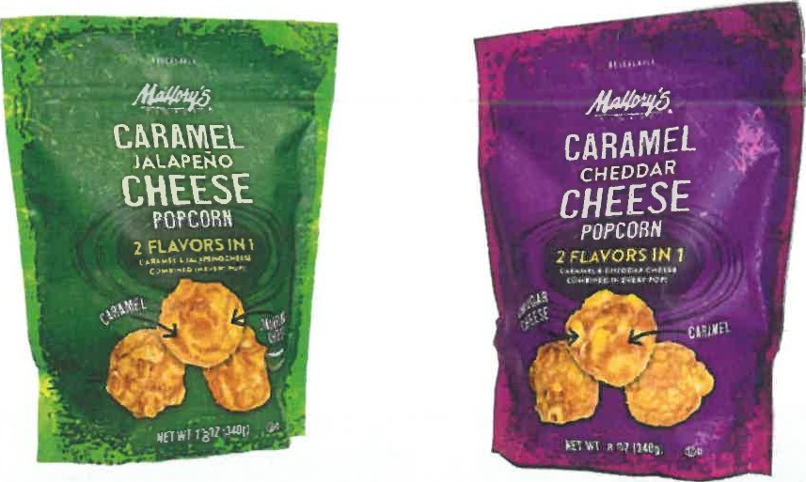

## PRICES & PRODUCT SUBJECT TO CONFIRMATION OF ORDER PRICES MAY CHANGE WITHOUT NOTICE



CHOCOLATES