Main Office

575 Old Hull Road

Athens, GA 30601

Phone 706-543-2502

Fax 706-543-4314

#### **2527A**

Ground Chicken Breast

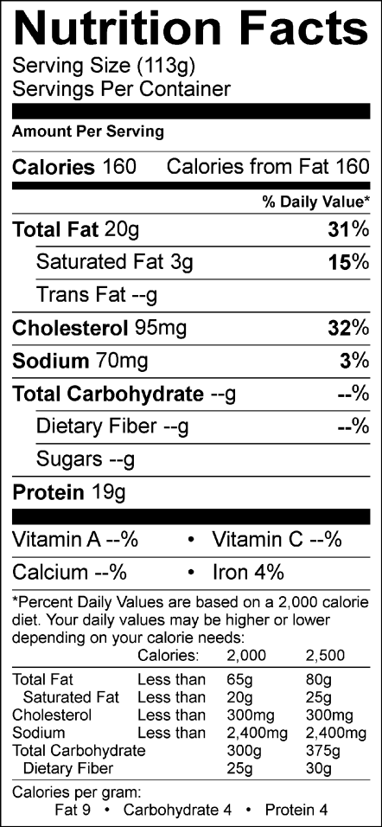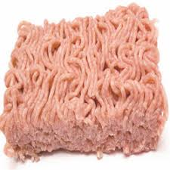

Ingredients

GROUND CHICKEN Breast with rib meat

**Coarseness screens**

50% 2mm

25% 1.5mm

25% 1mm

**Grind**

3/16” Grind

## MICROBIOLOGICAL

Standard Plate Count <100,000 cfu/g

Coliform <1,000 cfu/g

E. coli <100 cfu/g

**PROPERTIES:**

**PHYSICAL** **LIMITS** **METHOD**

Appearance Good, Normal Chicken Q.A. Inspection

Flavor Free of off flavor and odor Q.A. Inspection

Foreign Material None allowed Q.A. Inspection

Bones None > ¾ Q.A. Inspection

Cartilage None> ¾ Q.A. Inspection

Product Handling & Storage

365 day shelf life at 0°F from pack date

Preparation and Cooking

Product is for further processing and cooked use only.

**Product Product Information**

**Code: 2527A**

**Case Weight: 40 lbs. net. Wt.**

**Case Dimensions: 22 13/16 X 15 9/16 X 4 1/40**

**Case Cube: .78**

**Tie/High: 5/9**

**Cases per Pallet: 45**